MS SQL SERVER
Standard Operating Procedures
(SOP)

Creation of SSIS job in SQL Server 2014

Submitted to



By



CIS, Wipro Limited

Document Details

Project Name | Innogy SE
Account | CIS
IT Component/Application Title | Creation of ssis job in sql server 2014
Current Version | 1.2
List of Contributors | Pradipkumar Kansara, Kiran Bhalekar, Ayushi Gautam, Sivakumar Goud, Pramod Patil
Customer Contact Information

Version History
(All revisions made to this document must be listed in chronological order. All revisions must be approved. Review and Approval can be done by an internal source or by the customer)
Version | Date of Revision | Description | Author | Reviewed By | Approved By
1.0 | 05-12-2017 | Initial Draft | Ayushi Gautam | Pradipkumar Kansara | Santosh Badiger
1.1 | 06-12-2017 | Document Completed | Kiran Bhalekar | Pradipkumar Kansara | Santosh Badiger
1.2 | 20-11-2018 | Updated the content | Pramod Patil | Pradipkumar Kansara | Santosh Badiger
Document Distribution List
Sr.No | Name and Company | Purpose
1 | RWEIT-SQLDBA | Document is useful for creating a SSIS JOB in SQL Server 2014

TABLE OF CONTENT
1. Purpose 1
2. Scope 1
3. Creating a SSIS Package 1
4. Reference 12

Purpose
This document is prepared for creation of SSIS job in SSMS for SQL Server Database Administration Services.

Scope
This document is prepared for SQL Wipro sustenance team and provides the concepts, and tutorials to create SSIS Job in SQL server and to deploy a SSIS package for the administration of the SQL Server database.

Create a SSIS Job

STEPS:
- Login to server > start > run [Windows+R] > ssms
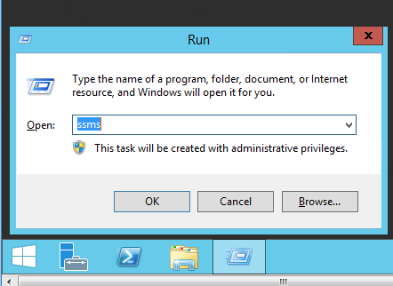
- Login to SQL Server > expane SQL Server Agent > Right click Jobs > New Job
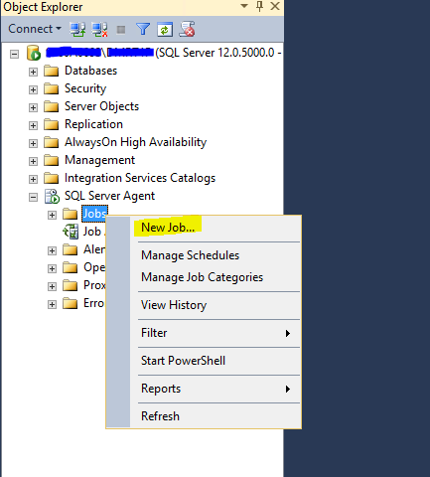

- Put the name of the Job > Owner should be SA > Select the proper Category of the Job > Go to Steps
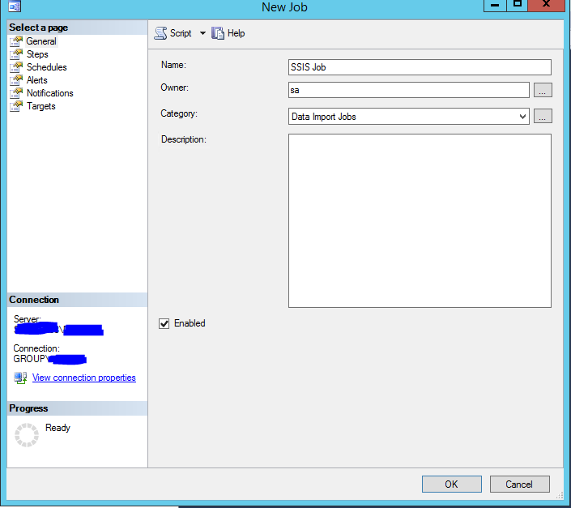
>New Step
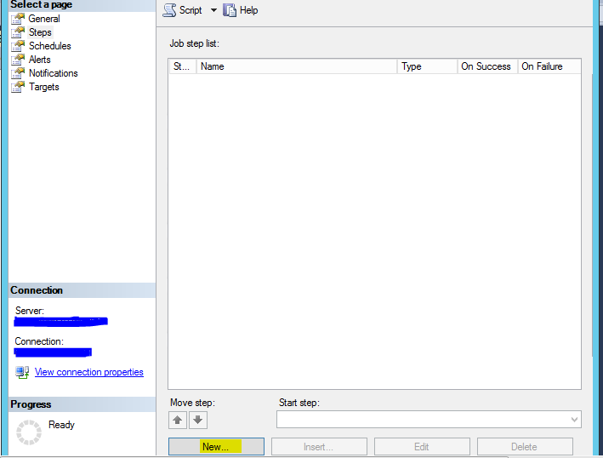

- Put step name > Type as “SQL Server Integration Services Package” > Run as SQL Server Agent Service Account > Package Source = File system > Go to Package > browse the package by clicking {…}
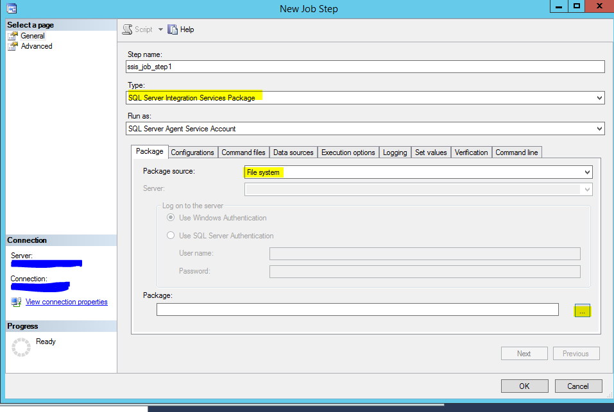
- Browse the SSIS Package saved on the disk
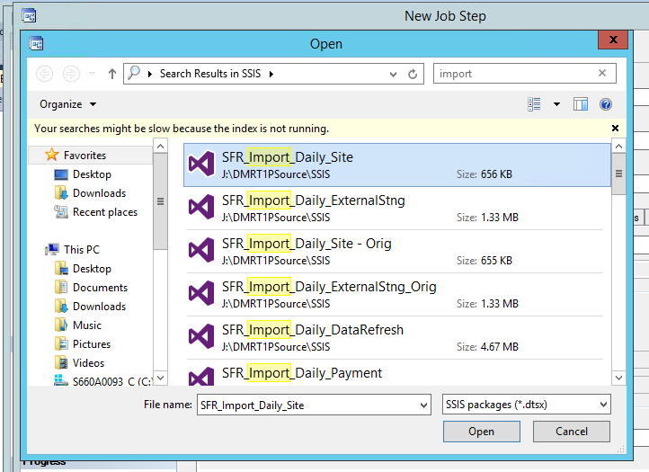

- Give the package
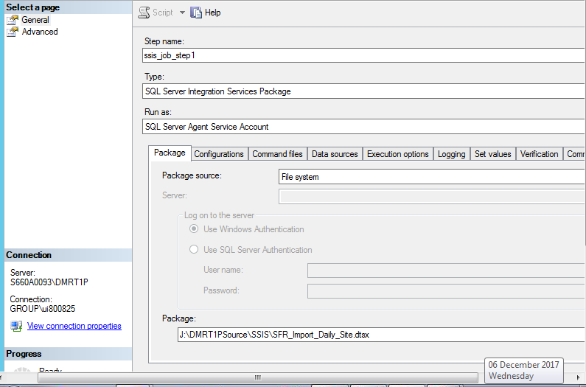
- Go to Configurations Tab > Add the configuration file (Only go for this step if it is application requirement)
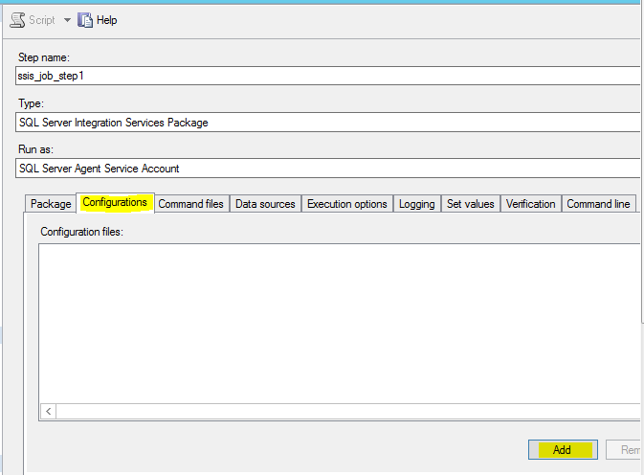
- Browse the Configuration file
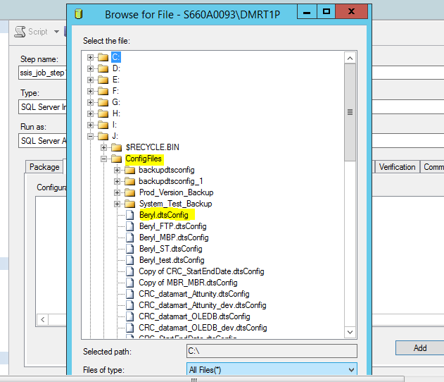

- Go to data sources tab, Check that mapping is right for connection manager and connection string
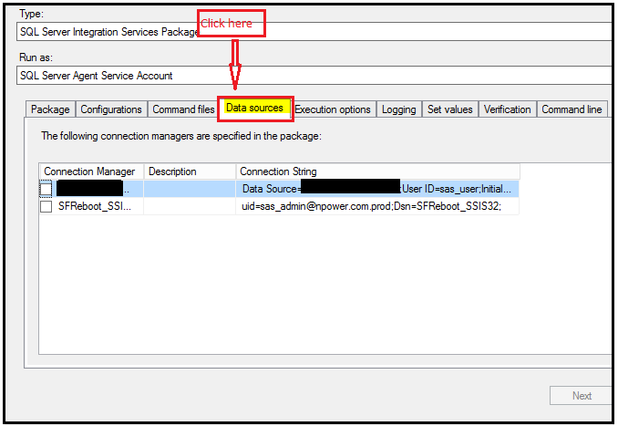

- Go to Execution options, if the package has any csv file or xls file and it has only 32 bit runtime compatibility, check this option otherwise the job will throw an error > don’t check it if there no such requirement
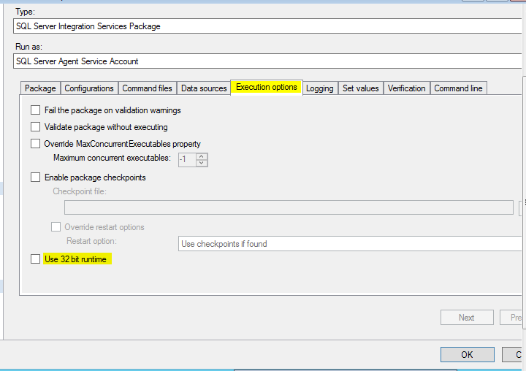

- Create the schedule as normal job schedule

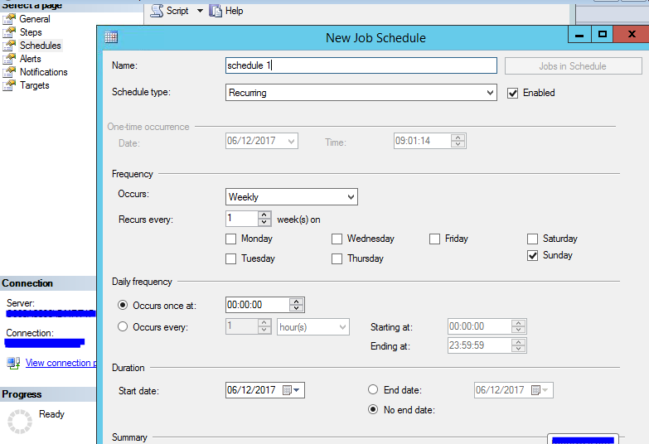

- Click OK > the job is created > Check it in the list of Jobs

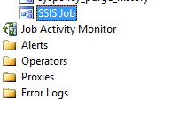

Reference
https://docs.microsoft.com/en-us/sql/integration-services/packages/sql-server-agent-jobs-for-packages

